Code Review: I2104013
Reviewer: James Wood
Date: November 30, 2023

Bugs

Preventative Action/Safety
- Credit Note must also be updated:
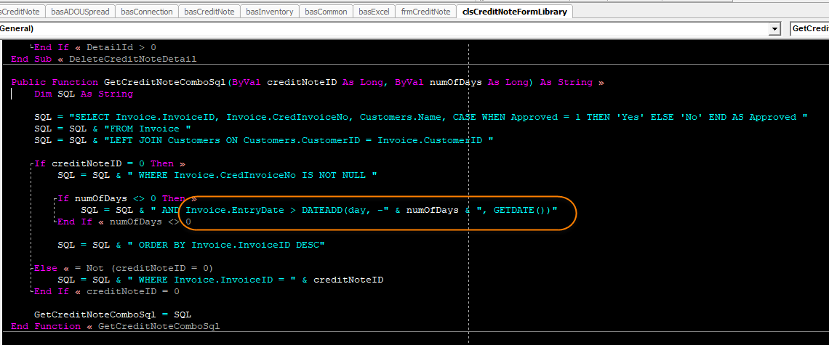

- This InvoiceNo filter within CreditNote also needs to be modified:
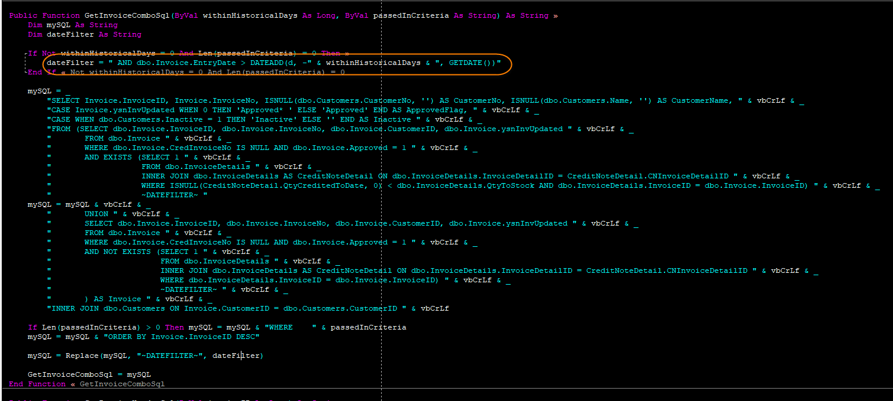

- Subcontracting also uses the DateAdd method. This should probably be changed, as well, even if it is Subcontracting.
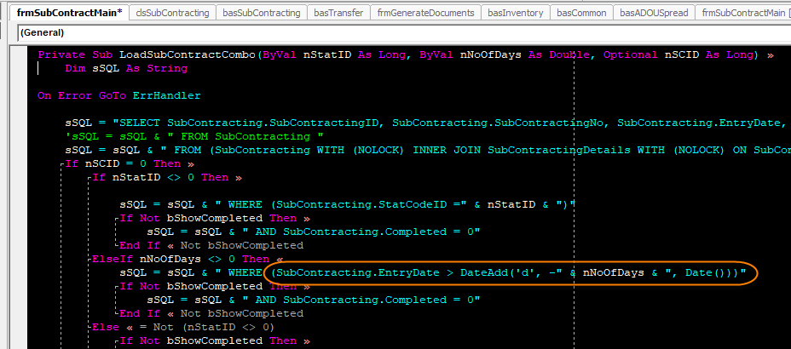

- Also ServiceOrder:
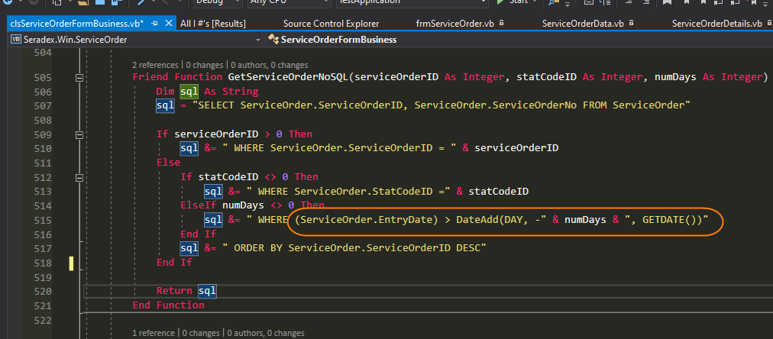

Design/Architecture (Duplication, appropriate project, namespaces, maintainability)

Data Model (Naming, good design, needs index?)

Performance (Minimize DB hits, excessive loops, queries, scalable)

UI (Alignment, naming, standardization, tab order)

Error Handling (Behind events, appropriate parameter checking)

Cleanup (Dispose code, remove handlers, large data objects)

Readability (Well-named variables, methods, clear algorithm, is it understandable)

Comments (Useful, explains why rather than how)

Message Boxes (Grammar, spelling, captions, appropriate icons)

Ticket Management (Release Branch?, Testing Notes)
- Nit: When writing Release Notes I think it’s best to keep it specific to the module that the change is for, instead of listing the general change. It’s also not entirely clear which combos were affected.
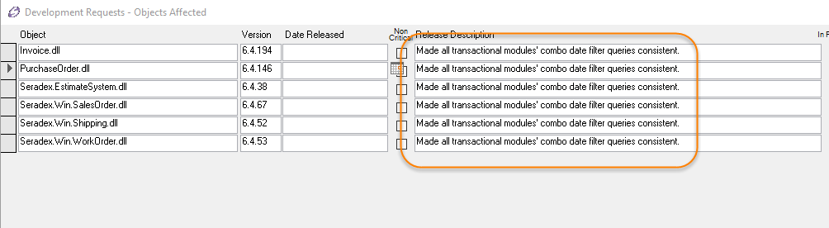

Perhaps something like, “Modified InvoiceNo combo date filtering to be consistent with other modules.”
- For the PO form change, I would also add an additional Testing Note to test the “Show Received” filter. While I don’t see anything wrong with the change itself, it is still a logical change that’s not covered by the ticket’s main issue so the Tester has no way of knowing to test this.
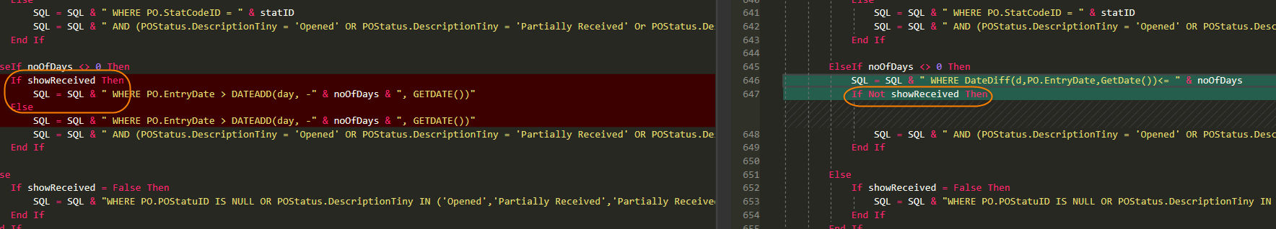

Extras

